

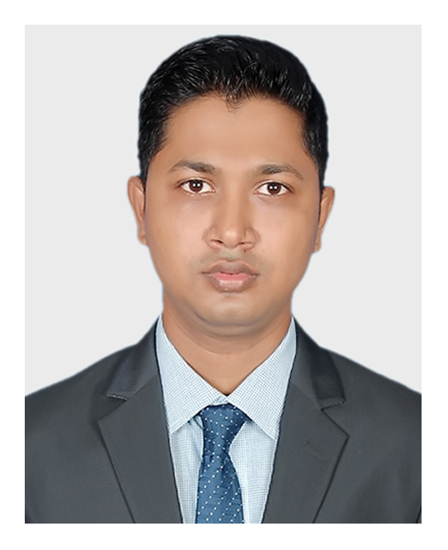

Md. Mizanur Rahman

**Career Objectives**

To work in an environment where there is an opportunity of self-assessment and self-improvement in both individual and group-based work that will ultimately lead to further development of the common people. And Looking for a challenging opportunity to sharpen my skills and knowledge in a fast-paced organization and to grow as a lead!

**Training**

1. **IsDB IT Scholarship Project** (Graduate on February 2021)

* Enterprise System Analysis & Design – JEE

**Skills**

**Languages :** Java, SQL.

**Frameworks :** Spring, JSF, Angular, Bootstrap.

**Libraries :** JQuery.

**Database :** MySQL, Oracle, SQLite.

**Others :** Git,GitHub, Html, CSS, JavaScript, NodeJs, Tomcat, Firebase.

**Concepts :** UML, Digital Marketing**.**

**Projects**

**1. Hospital Management & Information System**

* Technologies Used: Java, Spring, Tomcat, Hibernate, MySQL, Jquery, Bootstrap
* [github.com/mizan404/SpringProject](https://github.com/mizan404/SpringProject)

**2. E-Voting Management System**

* Technologies Used: Java, Swing, MySQL
* [github.com/mizan404/All-Swing/tree/master/vote_management](https://github.com/mizan404/All-Swing/tree/master/vote_management)

**References**

**1.** **Moshaidul Islam**

IsDB-BISEW, Consultant of IsDB-BISEW

01711 071 219

[moshaidul@gmail.com](mailto:moshaidul@gmail.com)

**2. Muhammad Maruf Hasan**

IsDB-BISEW, Instructor of IsDB-BISEW

01844572302

[maruf.tcl@gmail.com](mailto:maruf.tcl@gmail.com)

**Mailing Address**

**Address:** 257-258, Rose Elegance,

Ibrahimpur Primary School Road, Ibrahimpur, Kafrul, Dhaka-1206.

**Phone: 01680225343**

**Email:** [mohd.mizanur16@gmail.com](mailto:mohd.mizanur16@gmail.com)

**Personal Info**

Father’s Name : Md. Babar Ali

Mother’s Name : Sultana Parvin

Date of Birth : 16th Nov, 1994

Gender : Male

Religion : Islam

Nationality : Bangladeshi

Marital Status : Single

NID : 5550086796

**Permanent Address**

Pachani, Alaipur (9240), Rupsha, Khulna.

**Education**

**MSS in Economics (On progress)**

University of Dhaka

**BSS in Economics (2018)**

CGPA: 2.99

University of Dhaka

**HSC in Humanities (2011)**

GPA: 4.60

Dhaka Board

**SSC in Humanities (2009)**

GPA: 4.06

Dhaka Board

**Language Proficiency**

Bengali: Native speaker

English: Professional working efficiency

**Follow Me**

GitHub: [github.com/mizan404](https://github.com/mizan404)

Linkedin: [linkedin.com/in/mizan404](http://www.linkedin.com/in/mizan404)

Facebook: [facebook.com/mizan404](https://www.facebook.com/mizan404/)

**Signature**